Arrays are the foundation of DSA, and most patterns start here. I have started my journey by solving the DSA problems in a structured pattern wise go for it.

prerequisite: I have learned about=t Arrays and practised Concepts: Iteration, insertion, deletion, reversing.

Lets get started! I have solved a problem in leetcode question number 189 Reverse an array.

problem: Given an integer array nums, rotate the array to the right by k steps, where k is non-negative.
Example outputs:

Example 1:
Input: nums = [1,2,3,4,5,6,7], k = 3
Output: [5,6,7,1,2,3,4]
Explanation:
rotate 1 steps to the right: [7,1,2,3,4,5,6]
rotate 2 steps to the right: [6,7,1,2,3,4,5]
rotate 3 steps to the right: [5,6,7,1,2,3,4]

Example 2:
Input: nums = [-1,-100,3,99], k = 2
Output: [3,99,-1,-100]
Explanation:
rotate 1 steps to the right: [99,-1,-100,3]
rotate 2 steps to the right: [3,99,-1,-100]

Solution my brain wrote at the POT
:
class Solution {
public void rotate(int[] nums, int k) {
int n = nums.length;
int[] arr = new int[n];

// Step 2: Place each element at its rotated position
for (int i = 0; i < n; i++) {
arr[(i + k) % n] = nums[i];
}
for (int i = 0; i < n; i++) {
nums[i] = arr[i];
}
}
}

Out put: unfortunately not a good code
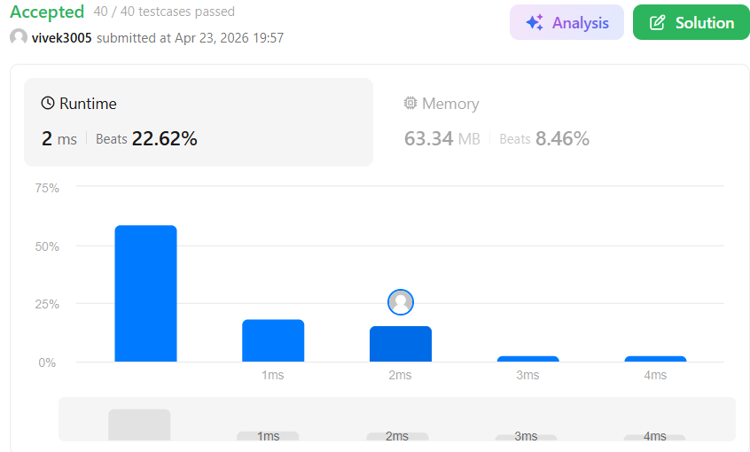
Let check out the top solutions:
class Solution {
public void swap(int[] arr, int i, int j){
while(i<j){
int temp = arr[i];
arr[i] = arr[j];
arr[j] = temp;
i++;
j--;
}
}
public void rotate(int[] nums, int k) {
k = k % nums.length;
swap(nums, 0, nums.length-1);
swap(nums, 0, k-1);
swap(nums, k, nums.length-1);

}
}

What is this approach?
